AI Surrogate Models for Pedestrian Travel Time Prediction in Architectural Spaces
Detthana Pattaphat
Chulalongkorn University
6872011825@student.chula.ac.th

Abstract
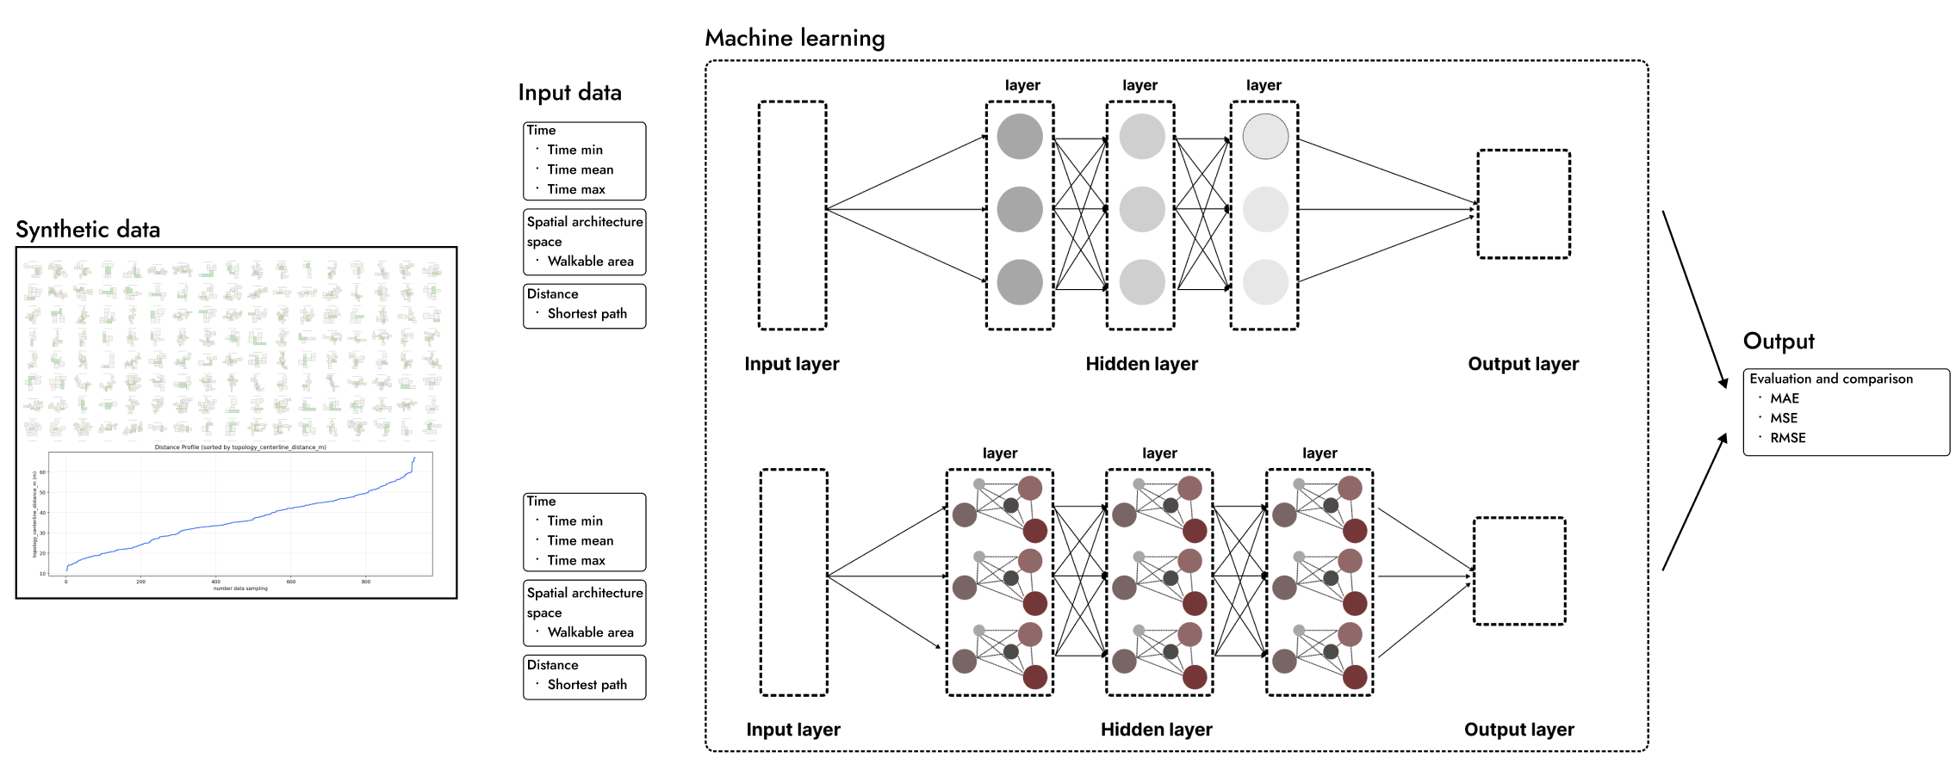

Pedestrian simulation is widely used in architectural design to evaluate movement patterns, spatial performance, wayfinding efficiency, and safety-related issues such as evacuation time and egress capacity. Conventional simulation methods often rely on physics-based approaches, among which the Social Force Model is widely adopted in both research and professional software. However, these methods can be computationally demanding, making them less suitable for early-stage design exploration, where multiple spatial alternatives must be assessed rapidly.
This research proposes the use of artificial intelligence (AI) surrogate models to approximate the outputs of Social Force Model-based pedestrian simulations. The study focuses on predicting pedestrian travel time within architectural spaces, which can support applications such as evacuation assessment, circulation analysis, congestion estimation, and wayfinding performance evaluation. The objective is to develop predictive models capable of estimating travel time from an origin point to a destination point under varying floor plan configurations, travel distances, and numbers of occupants. Training data were synthetically generated using JuPedSim.
The methodology involved creating a dataset comprising 600 architectural layouts and 3,400 travel scenarios, with variations in spatial configuration, origin–destination conditions, travel distance, and agent quantity. All scenarios were constrained to a single-destination movement task at the operational layer of pedestrian simulation. Two AI models were trained and compared. A Multi-Layer Perceptron (MLP) was used as a feature-based regression model to predict travel time from encoded spatial and numerical parameters. A Graph Neural Network (GNN) was used to represent architectural spaces as graph structures, allowing the model to learn spatial connectivity and path relationships.
Model performance was evaluated using Mean Absolute Error (MAE), Root Mean Squared Error (RMSE), Mean Squared Error (MSE), and parity plots. The results show that the MLP achieved lower travel-time prediction errors than the GNN, with approximately twice the predictive accuracy. However, the GNN showed stronger potential for capturing movement-path relationships across both short and long-distance scenarios. The contribution of this study is the formulation of pedestrian travel-time prediction as a design-oriented surrogate modelling problem, linking spatial configuration, origin–destination relationships, and occupant quantity to quantitative performance indicators. These findings suggest that AI-based surrogate modelling can support rapid pedestrian performance evaluation in early-stage architectural design, while further research is needed to improve generalisability and graph-based spatial representation.
ตอนนี้ได้ 330 คำ ต้องขยายความในส่วนของ Result ให้ละเอียดกว่านี้นิดหน่อยจ้ะ

Keywords:
Pedestrian simulation;
travel time prediction;
wayfinding;
Multi-Layer Perceptron (MLP);
Graph Neural Network (GNN);
AI-based simulation.

Reference
Helbing, D., & Molnár, P. (1995). Social force model for pedestrian dynamics. Physical Review E, 51(5), 4282–4286. https://doi.org/10.1103/PhysRevE.51.4282
Berggold, P., Nousias, S., Dubey, R. K., & Borrmann, A. (2023). Towards predicting Pedestrian Evacuation Time and Density from Floorplans using a Vision Transformer. arXiv:2306.15318. Retrieved June 01, 2023, from https://ui.adsabs.harvard.edu/abs/2023arXiv230615318B
Zhou, J., Cui, G., Hu, S., Zhang, Z., Yang, C., Liu, Z., Wang, L., Li, C., & Sun, M. (2018). Graph Neural Networks: A Review of Methods and Applications. arXiv:1812.08434. Retrieved December 01, 2018, from https://ui.adsabs.harvard.edu/abs/2018arXiv181208434Z
Hornik, K., Stinchcombe, M., & White, H. (1989). Multilayer feedforward networks are universal approximators. Neural Networks, 2(5), 359–366. https://doi.org/10.1016/0893-6080(89)90020-8

Clever, J., Abualdenien, J., Dubey, R. K., & Borrmann, A. (2023). Predicting occupant evacuation times to improve building design.
Tanaka, F., Amano, T., Uchiyama, A., Hiromori, A., & Yamaguchi, H. (2026). Rapid Policy Impact Estimation for Pedestrian Flow Using Neural Network Surrogates Companion Proceedings of the 27th International Conference on Distributed Computing and Networking,

